Running Judgments:
How We Really Know What We Really Know

One nagging philosophical problem of knowledge is that although it seems that we can know, it is hard to say how we know. One of the main troubles in this regard is when, if ever, we are justified in being convinced that something, p, is true even though the evidence is never completely in. Assuming only a finite amount of evidence to be sifted, prudence suggests withholding judgment until all the evidence is in and duly analyzed. But it is arguably the case the evidence is never all in. This leads either to the pessimistic conclusion that we can’t know because we never have enough evidence or to the search for a “fallible” standard of justification: one that gives us sufficient reason to be convinced that p even though possibly p is false.

The dilemma is that of choosing between a standard of justification which seems weak and even wishy-washy and that we have no knowledge at all. On the one hand, we sympathize with the ideal of perfect, comprehensive knowledge, even though we can see it is out of our reach. From there we struggle with the notion that anything imperfect, in which justification does not guarantee truth¸ deserves to be called knowledge. The predicament we are in is that for any claim p at any frozen instant in time there is a noticeable gap in the evidence we have and the evidence we yet lack that would warrant the conclusion that p. The question is: what, if anything, can give reason for us to ignore that gap and conclude that p anyway?

Here I propose that in a sense we must choose both horns of the dilemma: for any claim, p, there is a sense in which we cannot know that p and another sense just as important that we can know p. The sense in which we can’t know p is in the form of “frozen” judgments; that is, on the basis of evidence considered at any one instant. The sense in which we can know p is in the form of “running” judgments, that is, judgments made over the course of time, whose justification is based on notice of the judgment approaching complete evidence as an asymptotic limit over the course of time.

Before getting to this, let me first go back and solidify the initial points made above in framing the issue: that it seems that we can know, that the evidence is never all in, and that fallibilist justification appears both weak and wishy-washy from a certain reasonable perspective not to be dismissed offhand.

It seems that we can know because, although we can’t point to any one perfect case, we can point to a whole spectrum of cases of knowing things more or less, with the best cases achieving certainty at least in a practical if not absolute sense. Included in these, e.g., are basic arithmetic truths, taxonomical facts, basic moral principles, and observed states of affairs.

In spite of this appearance, we must concede that the evidence is never all in. For we never complete science or mathematics and will never be able to say exactly what numbers are; these two impugn any claim that my knowledge even that two plus two equals four is comprehensive. Nor can I ever know myself or anyone else completely, nor the solar system. There are always a countless infinity of things left to observe or to be noticed.

In response to this, a fallibilist theory of justification seems to be in order, one in which justification does not guarantee truth. But this seems to leave us with an arbitrary line or even lines to draw. When is it time to pull the trigger and make a decision? No single point in time stands out as decisive with respect to any of the others. This option seems wishy-washy as well, since the decision about where to draw the line on a matter seems to be affected by what the stakes are. Yet it seems odd to say I know p when less is at stake but not when more is at stake.

For example, we typically grant that one knows one has a cavity that needs filling based on the dentist’s diagnosis. In contrast, we typically would not grant the same if the issue is brain surgery, even imagining the diagnoses both to be straightforward and of similar complexity. It is odd that we should know p and not q on the same amount and quality of evidence simply because q is more important.

So, the problem to be addressed is this: in order to know something p in time, there must be a finite way of processing evidence toward its justification. But since the evidence is never all in, it seems there can be no finite process of justification, either. Hence it seems we can’t know; in particular, because we are always infinitely far from the ultimate goal of complete evidence. No matter how much progress we make toward complete evidence, we never get any closer to it, so at no time is there ever reason to “pull the trigger” and conclude “I know this”. We can represent this in the following linear model:

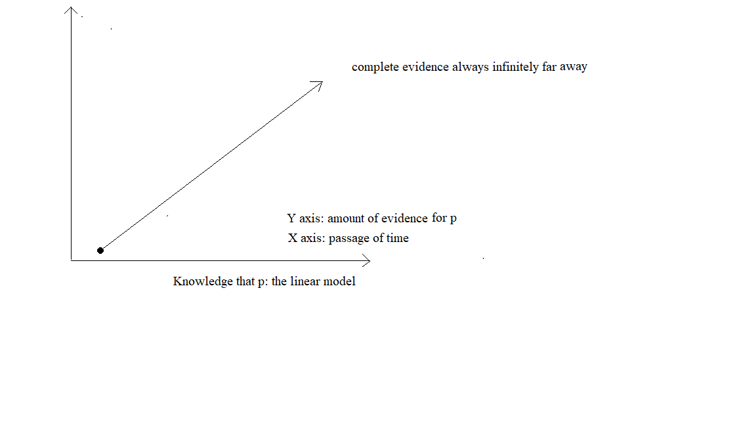

This graph represents a dreary picture for would-be knowers leading to the conclusion that not only can we not know, but there is also no point even trying. This by far surpasses the skepticism of, say, Socrates, who though doggedly insisting that he knew nothing – and by implication no one else among company then present – made it clear that it was well worth trying to know, so much so that he considered the method of dialog he practiced to be a “divine activity”. If Socrates is right, then there must be something incorrect about our first graph, in that it fails to accurately characterize our process of knowing, however ill-omened it may turn out to be. For Socrates, whose claim not to know is based on an “either-or” perfect notion of knowledge, there seems also to be a more-or-less imperfect notion of knowledge motivating him, so much so that it became for him a cause worth dying for.

What is needed is a way of distinguishing between these two kinds of knowledge, one of which is not achievable, while the other is more or less achievable. This can be summed up by saying that although we cannot have perfect knowledge, we can be closer to or farther from knowing something. If this is the case, then complete evidence cannot be infinitely far away. But how can it not be infinitely far away if getting to it requires an infinite process, as we have already argued above?

The answer is that in the sense we can know, we approach complete evidence infinitely not as something infinitely in the distance, but as an asymptotic limit. What we need, then, is a graph that can represent this way of knowing, and a suitable explanatory narrative to go along with it, while representing also the more perfect way of knowing that we cannot achieve. Consider the following graph:

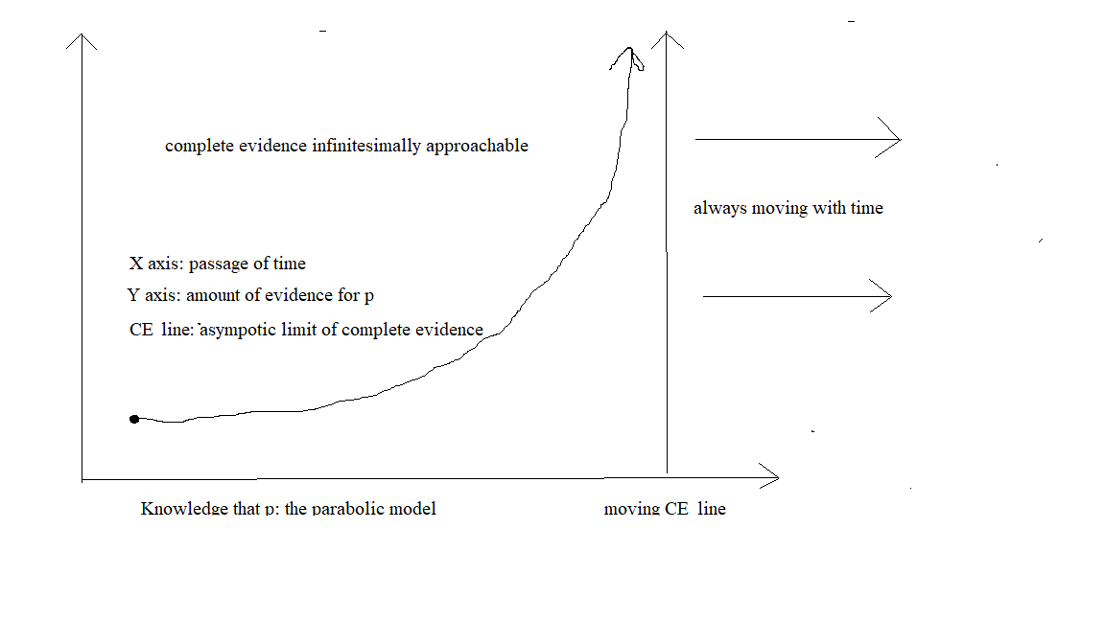
Like the earlier graph, this graph charts the experience of the development of a belief in the claim p over the course of time, represented by passage from left to right along the horizontal X axis. The Y axis represents measurement of increase in evidence according to some optimal algorithm taking into account quality and quantity of evidence. The CE line represents an asymptotic limit of complete evidence to which the approaching curve can be in theory over an infinite course of time even infinitesimally near, but in any finite course of time will always be at a measurable distance. The CE line is always moving ahead of the approaching curve over the course of time but never allowing the curve to touch it.

This gives us a way to visualize how we can know what we know and not know what we can’t know. For judged at any one time in a finite passage of time, this graph will always reveal a noticeable discrepancy between the oncoming curve and complete evidence (the CE line), giving us reason to deny that p is ever justified at any one point along a finite passage of time. On the other hand, this graph also allows us to envision the distinct possibility and likelihood of a belief approaching complete evidence as an asymptotic limit. Under that assumption, p can be considered justified, since a function approaching an asymptotic limit can be considered eventually to be only negligibly distance from it. If the growth for evidence for p is a pattern which eventually becomes only negligibly distant from complete evidence, then surely in this sense – that is, the sense of a running judgment - p is justified.

The fact is, whether we know how to do math or not, or are able to draw or read graphs, we know an infinite function when we see one, especially one with an asymptotic limit. Of course, even our knowledge of whether a judgment is a function infinitely approaching an asymptotic limit and therefore is justified as a running judgement is a running judgment. Running judgments are not justified at any one time, but over the course of time.

To those who demur on the grounds that it would taken a very long time build up a sufficient data
base to conclude with high probability that one of our judgments approaches complete evidence
as a limit, I respond by noting that it is not just the extensive build-up of data that can reveal such
patterns, but intensive build-ups as well. Compare my own judgment of my health with the
judgment of my doctor. While my doctor has data points separated by one year and seeks patterns among those points, the data points of my judgment can be as fine-grained as I want them to be. Since I am always experiencing my body, I can consult data points even continuously over time, giving me an infinite data base to draw from. To be sure, the data is not the same, and the data collected by my doctor is something I need to be more knowledgeable about my health, nonetheless it is just as true that my doctor needs me to share with him what I know about my health.

Whatever we know, we know in the form of running judgments. We are incapable as finite reasoners to know in any other way. It is not quite the same thing as inductive knowledge, which is more strictly mathematical. Running judgments differ from inductive inferences in that the latter change and are subject to recalculation with every new observation, and so technically of short duration: from 70% to 71% to 72% likelihood, etc. Running judgments are of long duration and do not get recalculated; they are merely recognized as approaching complete evidence and continually monitored for a break in the pattern, which would falsify the judgment. In the absence of a break, they are understood for what they in all probability are, as one single ongoing judgment, true and justified.

There is no magic to this, as it might seem to some, other than the intuitive pattern recognition that allows us to lock in definitely on so many other things even before we have extensive knowledge of them, such as the many species of natural kinds. In spite of their many different sizes, shapes, and colors, we know dogs enough to distinguish them from other natural kinds even before we can say “that is a dog”.

The friendships we form are based at least in part on running judgments of moral character, judgments made and built on and maintaining their identities as judgments for years monitored only for a break in pattern that grows ever less likely with the passage of time. The continued growth in evidence does nothing to alter the judgment, as it would with judgments of bare mathematical probability, which would have to be recalculated with every new data entry.

This vision of the knowledge we have as running judgments rather than frozen judgments does much to explain away some of the puzzles we have about knowledge. As running judgments, there is no arbitrary choice to be made as to how much evidence is enough. With running judgments, the door always remains open, for the judgment is not made on the basis of calculations over evidence, but on the recognition of a pattern. Once the pattern is at first recognized, our minds are made up – not to close the books, but to keep them open for a lifelong study of the thing, from that time on homing in as close as needed to our continuous database.

We can also recognize more easily by this explanation what we cannot know: frozen judgments. Thus, the quandary regarding how we can know we have a cavity that needs filling by the mere report of our dentist, but not that we need brain surgery by a similar report of a specialist, by saying that we really don’t know any such thing, but fall back to background running judgments about the wisdom of forming trust relationships with professionals helping us in ordinary situations and obeying in minor matters, while at the same time taking pause when more is at stake. When my dentist says I have a cavity that needs filling and I have no evidence of it in my own experience nor can spot it in the x-rays shown to me, I really am not justified in believing I have a cavity that needs filling, but only in most cases that I am best off obeying dental health professionals in minor matters such as these.

Finally, this explanation allows us to clarify the nature of Socratic skepticism, which consists in both denying that we know and insisting that we do all we can to approach knowledge. Knowledge in the perfect frozen sense is unattainable by us, while knowledge in the form of running judgments approaching complete evidence as asymptotic limits describes the approach to knowledge that Socrates so vehemently urged.

It is not that our infinite process of knowing yields no fruit, as if knowledge were always ever distant from us. The infinite process consists rather in the asymptotic approach to that to which we are infinitesimally near, in the form of running judgments.

